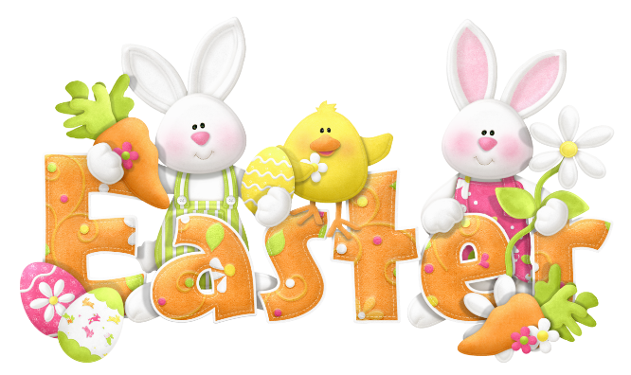
KHA EASTER PARADE

Saturday, March 27th, 2021 (2:00pm-4:00pm)
The Easter Bunny will be making an appearance in the Kimberlea Neighborhood.
We are having an easter parade. The Easter bunny will be in a convertible driving through the KHA neighborhood throwing out individually wrapped candy in Ziplock bags to our neighborhood children. If you would like to decorate your car and join the Easter Parade, please contact
Audrey Batchelor for more details.
kimberleahoa@gmail.com
We will be lining up at Wells Elementary School at 1:40pm, Saturday, March 27 for the Easter Parade. The Parade will begin at 2:00 pm starting at Buckle Lane. Please see map below.
